**Lab 3**

**Name: __Udayraj Suthapalli________ (Also, click on the header and enter your full name)**

**Note:** The word document of this assignment can be downloaded from CANVAS course page.

Please first read instructions and/or examples below and then **answer questions** **in the highlighted box**. **You are required to show the main steps of manual calculation for each question.** The SAS probability tools can be utilized to confirm your calculation results.

Go to **Tasks and Utilities** and then expand **Combinatorics and Probability** to use the available tasks as below.

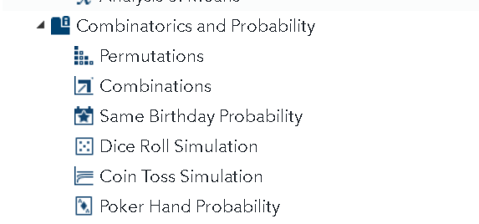

**Same Birthday probability**

In a year, there are 365 days. If you select two students in a classroom, what is the probability of them to have the same birthday? Well, for both to have **any specific day** as birthday, there is (1/365)*(1/365) chance. However, we have 365 days in a year and any day in a year can be their birthday, so we need to add up the probabilities of any day being for their birthday across all possible days. Hence, the probability of two people having the same birthday is 365*(1/365)*(1/365) = 0.00273972602.

Alternatively, we can find the probability of the two having different birthdays and calculate the complement (opposite). Any day in a year for the first person is unique. Therefore, the first person has 365 different ways to have a unique birthday in 365 days (365/365). After we have a unique birthday for the first person, now there are 364 different days (out of 365) for the second person to have a unique birthday (364/365). Therefore, the probability of the two people to have different birthdays is (365/365)*(364/365) = 0.99726027397. Then taking the opposite probability, 1-0.99726027397, we get the same result.

To verify our calculation, we can use SAS Studio’s **Same Birthday probability task** and select the “**Number of people in a room**: **2”** to find the probability.

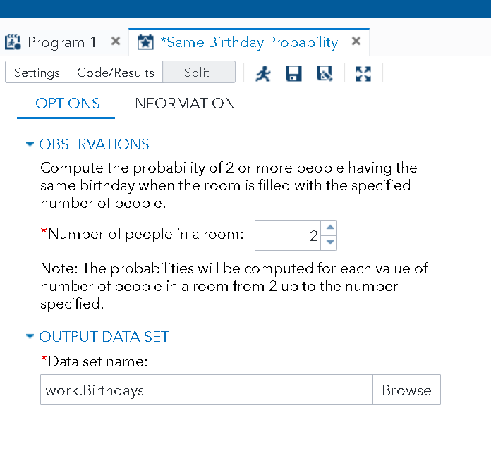

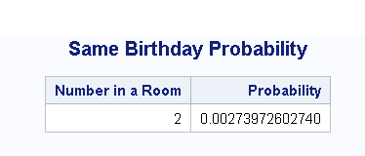



Use SAS Studio or calculate by hand to answer the questions in Box 1.

|  |
| --- |
| **BOX 1** |
| 1. If there are **3** students in a classroom, the probability of 2 or more people to have the same birthday is ____0.0027397260273_______ 2. If there are 23 students in a classroom, the probability of 2 or more people to have the same birthday is ___________ |

**Dice Roll Simulation**

If you roll a fair die, what is the probability of getting a four? Is it 1/6? If you try it at home by rolling a fair die and record the results, you will be surprised to see that it is not 1/6 in a few trials. As shown in our book, the probabilities are off in a few trials, but, if you repeat trials almost infinite times, the true probability can be approximated.

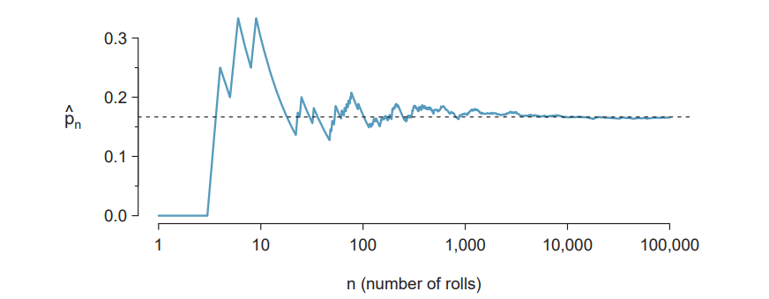

To get the theoretical results, we will set Number of dice to 1 and Number of Rolls to 100,000,000 in Dice Roll Simulation Task in SAS Studio, shown below.

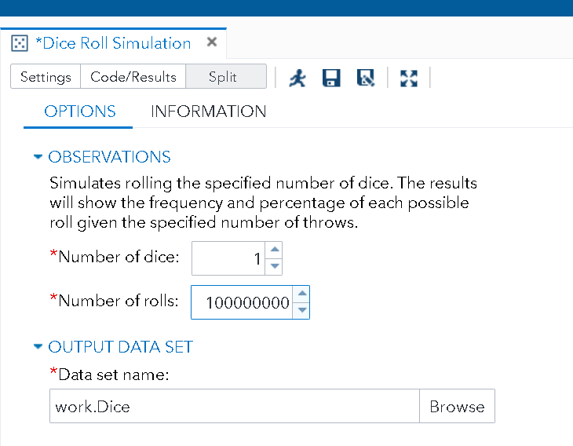

Click on Run to get below results.

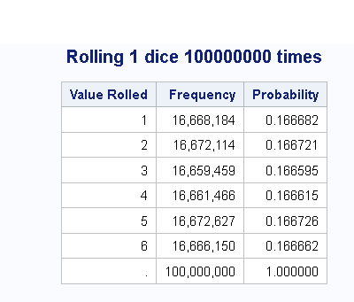

The chance of getting four is 0.166615. You might get a slightly different number (because the process is random), but the difference should be negligible.

What if we roll two dice and look at the sum? Just set the **Number of dice** to 2.

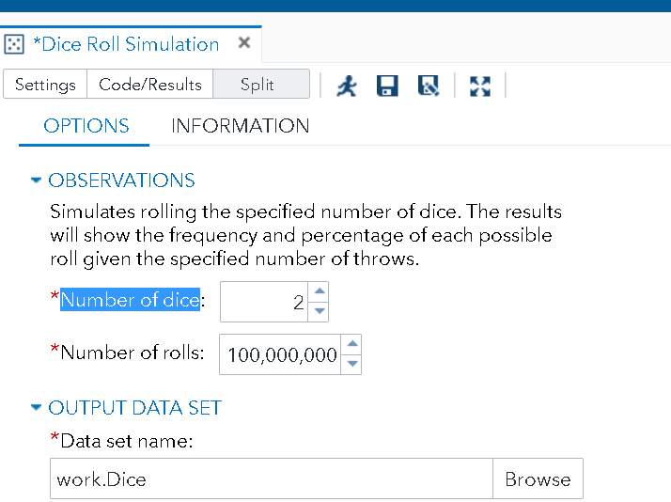

The result is as follows.

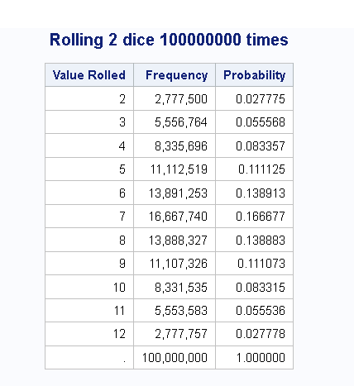

Mathematically,

* If we roll two dice, the probability of having a sum of 2 is P(1)*P(1) which is (1/6)*(1/6) = 0.027777777. In our SAS output, it is 0.027775, very close.
* If we roll two dice, the probability of having a sum of 7 can be achieved in multiple ways: (1,6), (6,1), (3,4), and (4,3), (5,2), and (2,5). So, the probability will be P(1)*P(6) +P(6)*P(1) + P(4)*P(3) + P(3)*P(4) + P(5)*P(2) + P(2)*P(5) = (1/6)*(1/6)+ (1/6)*(1/6)+ (1/6)*(1/6) + (1/6)*(1/6)+ (1/6)*(1/6) + (1/6)*(1/6)= 0.1666666666. In SAS, it is 0.166677, very close.

Now, use SAS or other tools to answer the questions in Box 2.

|  |
| --- |
| **BOX 2** |
| 1. If we roll **a** fair die, the probability of having **5** on the top is ___0.1666666667______ 2. If we roll **two** fair dice, the probability of the sum to be **11** is ___0.0555555555555556______ 3. If we roll **five** fair dice, the probability of the sum to be **5** is __ 0.00012860082___ 4. If we roll **five** fair dice, the probability of the sum to be **6 or less** is _ 0.00077160493________ 5. If we roll **two** fair dice, the probability of the sum to be **11 or more** is __ 0.0833333333333333_______ |

**Coin Toss Simulation**

If we flip a coin twice, the number of heads in each trial (let us call it random variable X) is a discrete number variable. (Note: flipping a coin twice or flipping two coins at once will generate the same random variable X). X can only take the following values: 0 (both tails), 1 (one head and one tail), and 2 (both heads). Now, what is the probability of getting two heads if we flip a coin twice? There is 50% chance for the first flip to be head, and 50% chance for the second flip to be head. Accordingly, the joint probability is P (H)*P (H) = 0.5*0.5= 0.25.

To verify above calculation in SAS Studio, we will use the **Coin Toss Simulation** task.

Under Tasks and Utilities, select Combinatorics and Probability and find **Coin Toss Simulation**. Set the Number of coins to 2 and Number of tosses to be very large like 100,000,000and click on Run.

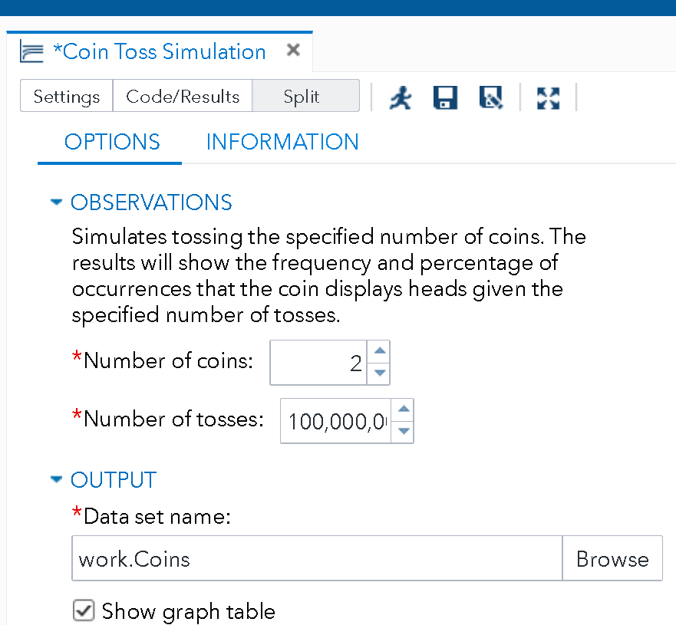

We will obtain the following output.

* The probability of getting 0 Head is about 0.25
* The probability of getting 1 Heads is about 0.5
* The probability of getting 2 Heads is about 0.25.



Use **Coin Toss Simulation** to answer the questions in Box 3.

|  |
| --- |
| **BOX 3** |
| 1. If we flip a fair coin **four** times, the probability of getting **four** heads is__0.0625______ 2. If we flip a coin **10** times, the probability of getting all **tails** is _0.0009765625__ 3. If we flip a fair coin **8** times, the probability of getting **four** heads and **four** tails is___0.125_____.   Survey question (no credit): I spent on average ____1hrs_________ hours to complete Lab 3. |